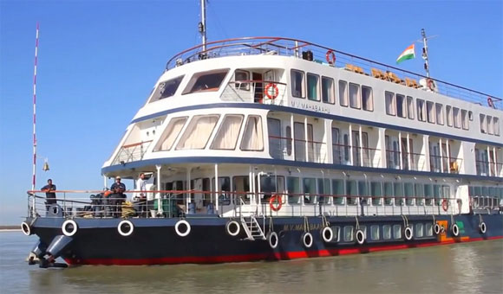
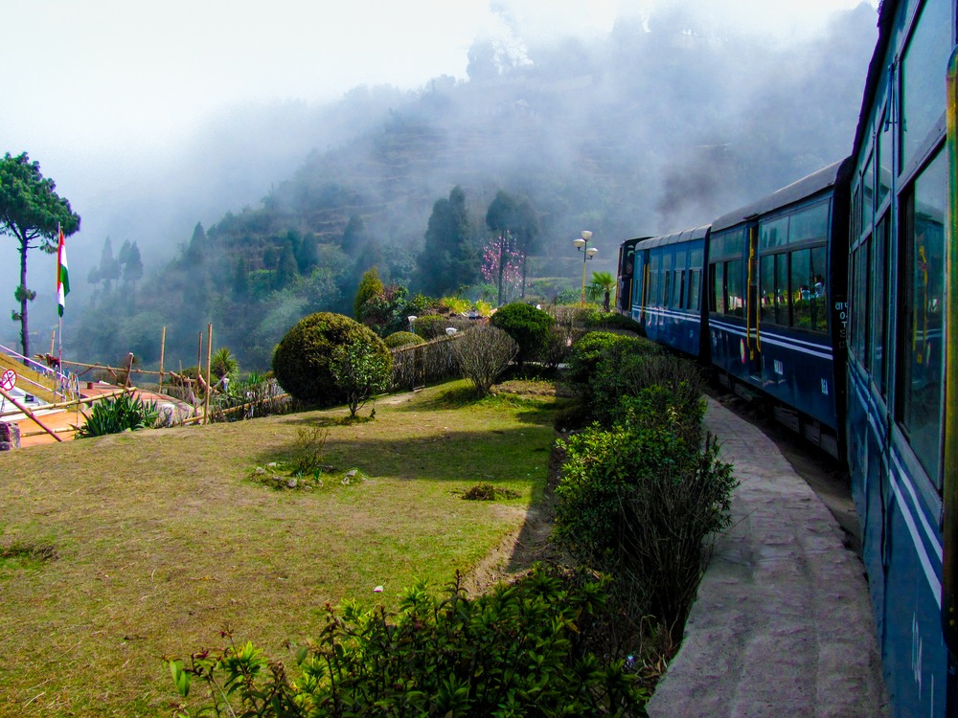
THE MAJESTIC NORTH EAST TOUR

Delhi - MV Mahabaahu Cruise – Guwahati - Darjeeling – Tumling – Darjeeling – Pelling – Gangtok
Program Highlights

- Luxury River cruise on Brahmaputra

- Options of various sightseeing in Delhi to choose

- Explore the virgin north eastern states

- Interaction with local people

- Safari in Kaziranga National park to spot the Rhinoceros.

- Experience a day trek in mountains

- Visit to monasteries of Darjeeling & Sikkim

DAY 01/FRIDAY ARRIVE DELHI

Arrive at New Delhi’s Indira Gandhi International airport.

Delhi - the capital of India – The city consists of two parts - Old & New Delhi. Old Delhi was the capital of Muslim India between 17th and 19th century and has many mosques, monuments and forts. New Delhi, the imperial city was created by the British as the capital of India. In 1911, Edwin Lutyens, the most renowned English architect of the day, was chosen to design New Delhi which flaunts a surprising number of impressive monuments related to its conquests by the Mughals, Turks, Persians and ultimately the British.

Meet & Assist: A dnata representative meets you at the arrival hall of airport, holding a signage of ‘dnata’ and escort you to your hotel in air-conditioned vehicle.

Check-in at hotel and stay for 2 nights.

Meals included: None
Overnight at hotel
DAY 02/SATURDAY DELHI

Breakfast at hotel

Later visit Old Delhi which was the capital of Muslim India between 17th and 19th century and has many mosques, monuments and forts. Begin your day with an exploration of Old Delhi - visit the Jama Masjid, the royal mosque built by the Mughal Emperor, Shah Jahan in 1656. It is one of the largest and most beautiful mosques in the world and is constructed in red sandstone and white marble. The main prayer hall has a seating capacity of more than 20,000 worshippers. In the old city of Delhi, walk through the by-lanes of the spice market, the wedding street and the jeweler’s lane to savor the 350 years old culture up-close. There will be great photo opportunities here.

Enjoy a cycle rickshaw ride through the narrow lanes of Chandni Chowk, the spine of Old Delhi. Jahanara Begum, the daughter of Shah Jahan designed this commercial place in 1648. Drive past Red fort, built in red sand stone by Shah Jahan in 1648, this magnificent monument is laid out along the river Yamuna as an irregular octagon. Drive through the majestic boulevards of New Delhi designed by the Edwin Lutyens in 1920. Lutyens' Delhi includes the grand government buildings and parliament house.

The Rashtrapati Bhavan (Presidential Palace) is where the Viceroy once lived and now is the official residence of the President of India. It is an imposing structure with 340 rooms, constructed high up on Raisina Hill. View India Gate, a war memorial arch built in honour of 90,000 Indian soldiers who lost their lives in World War.

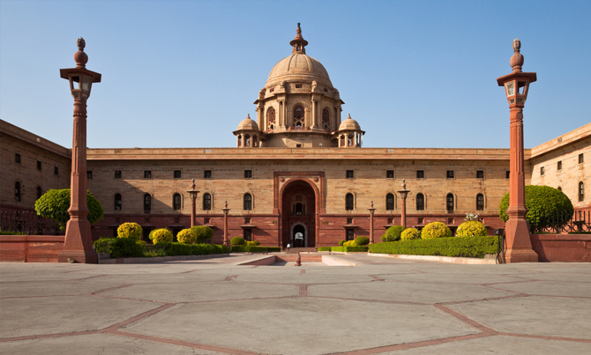
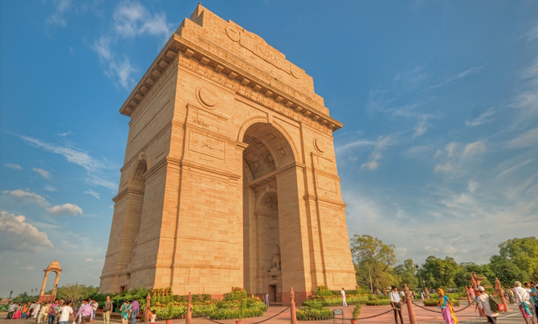
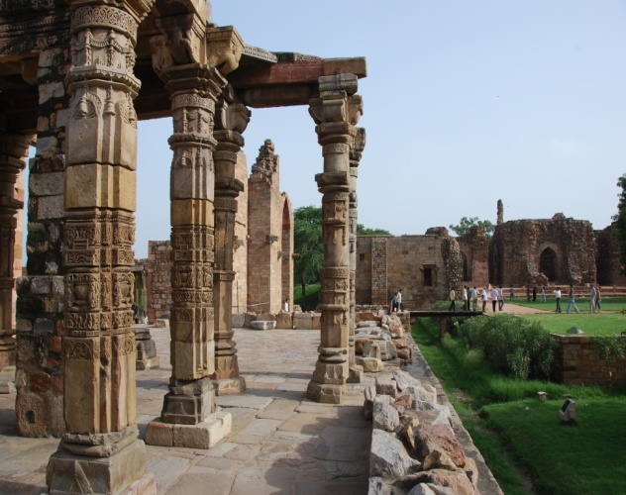
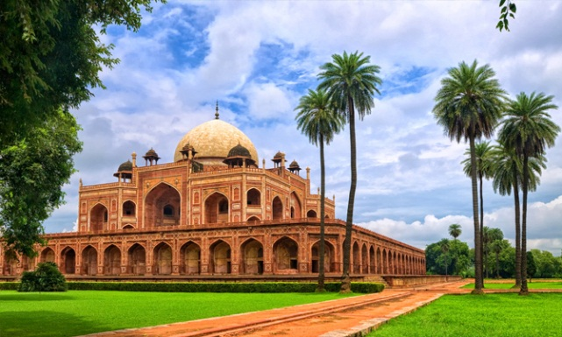
Continue to Humayun’s Tomb, the first great example of Mughal architecture in India, it developed to become the hallmark of the Mughal Dynasty. Culminate your tour at Qutab Minar, a soaring tower of victory, 72.5meter high with five distinct stories. The construction of this minaret commenced in 1193 and was completed in 1368. Built on the foundation of a Hindu temple, many elements of the construction reflect their Hindu and Jain origins. Within the complex, there are myriad monuments that combine both Islamic calligraphy and Hindu motifs.

Return to hotel after the above visits.

Optional-1: Evening enjoy a spectacular Bollywood entertainment show at a Grand Theatre “Kingdom of Dreams. Right from live theatre to food to shopping, Kingdom of Dreams has it all. Two of the most famous shows playing at Kingdom of Dreams are Zangoora - The Gypsy Prince and Jhumroo, a musical tribute to legendary singer Kishore Kumar. Nautanki Mahal is the venue of these two shows, which is built in a state of the art manner, complete with matrix sound system for a more real and enjoyable theatre experience. To enjoy arts and culture from across the country head to the Culture Gully in the Kingdom of Dreams. Spread over an area of 1, 00,000 sq ft there are restaurants representing 14 states from across India. Each restaurant has a unique theme and showcases something unique about the state. The Culture Gully has two lounge bars, the Mekhana Bar and the Kerala Bar.

Note: Evening show followed by dinner is recommended. It is closed on every Mondays.

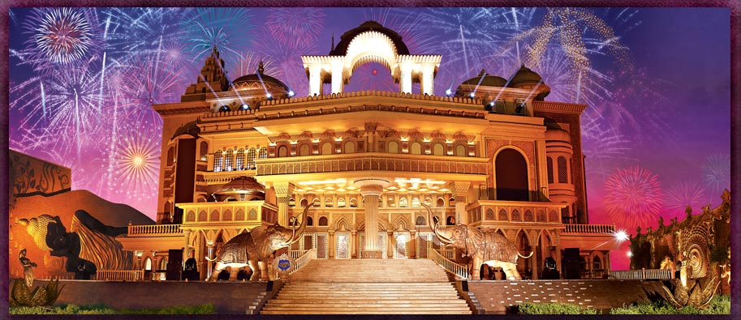
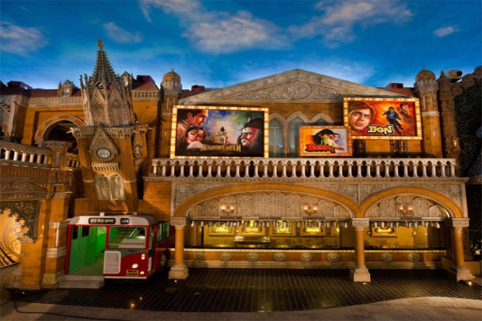

Optional-2: Salaam Baalak Trust City Walk: Salaam Baalak Trust is an Indian non-profit and non-governmental organization which provides a sensitive and caring environment to street and working children in Delhi, India. The Salaam Baalak Trust City Walk is an English guided tour of almost 2 hours conducted by kids who used to live in the streets of Delhi before joining our Trust. The guides are adolescents who have been fully trained as local guide and who want to improve their communication and speaking skills. City Walk gets the children's stories heard, gives people a view of their world through their eyes. Those who take the City Walk tour through the streets of inner city of Paharganj and the area around New Delhi railway station, led by a child who was once living and working on the streets will experience special tour far from the tourist main attractions. City Walk is an example of how a volunteer's creativity can translate into a unique and enduring programme, which is both popular and economically viable.

Optional-3: Visit to President House Museum: The Rashtrapati Bhavan Museum Complex, includes, the Garages Museum and Clock Tower in addition to the Stables Museum. is spread over 10,000 square meters and is a hi-technology story-telling museum. This museum depicts the story of the planning and construction of Rashtrapati Bhavan; the British Viceroys who occupied the building till 1947; their reaction towards the freedom movement in the country; transfer of power; formation of the Republic; life and work of 13 Presidents of India since 1950; life in Rashtrapati Bhavan; beauty and environment of the campus, people working here and important visitors to Rashtrapati Bhavan etc. The museum also has an Art Gallery for holding temporary exhibitions.

The Museum Complex is open all days from 0900 hrs. to 1600 hrs. Except Mondays.

Note: The slot needs to be booked well in advance (before one month) after registering online on their website. Slot is subject to availability and approval from the government officials.

Optional-4: Heritage Walking Tour in Old Delhi with an Historian
This morning enjoy a heritage walking tour with an historian. Begin your day with an exploration of Old Delhi - visit the Jama Masjid, the royal mosque built by the Mughal Emperor, Shah Jahan in 1656. It is one of the largest and most beautiful mosques in the world and is constructed in red sandstone and white marble. The main prayer hall has a seating capacity of more than 20,000 worshippers.In the old city of Delhi, walk through the by-lanes of the spice market, the wedding street and the jeweler’s lane to savor the 350 years old culture up-close. There will be great photo opportunities here. Later enjoy a cycle rickshaw ride through the narrow lanes of Chandni Chowk, the spine of Old Delhi. Jahanara Begum, the daughter of Shah Jahan designed this commercial place in 1648. Drive past Red fort, built in red sand stone by Shah Jahan in 1648, this magnificent monument is laid out along the river Yamuna as an irregular octagon.

Optional-5: Delhi by Cycle Tour
Visiting Delhi by Cycle offers five fascinating routes, covering the most interesting, intense, historical and beautiful areas of Old and New Delhi. Each of the tours is beautiful and interesting in its own way, with a unique focus, taking you to the hidden wonders of the city. Cycle tour offers you to become a part of the unique mix of colours, smells, sounds, tastes and unforgettable images. Take the tour and experience the city of Delhi with all your senses. Begin your Cycle tour early morning from Old Delhi to see sights like Turkman Gate, Chawri Bazar, Fatehpuri Masjid, Spice Market, Madras Colony & Civil Lines (chai OR tea break), Old Delhi railway station, Chandni Chowk - Red Fort (from outside), Jama Masjid (from outside) and breakfast at the famous Karim's restaurant.

Meals included: Breakfast
Overnight at hotel
DAY 03/SUNDAY DELHI – JORHAT – MV MAHABAAHU

After breakfast transfer to Delhi airport to board a flight to Jorhat.

On arrival at the Jorhat, we are met at the receiving area and with packed lunch, we drive to Neamati Ghat to board the MV Mahabaahu. (MV MAHABAAHU SETS SAIL AT 15:00 HOURS)

We check into our cabins and immediately gather in the restaurant for the essential safety briefing and to experience the first sail. All gather on the open deck to enjoy the first sail and scan the river for a fleeting sight of the Gangetic Dolphins.

We proceed into the evening with a talk on ‘Sibsagar and the Ahom civilization’. Soon MV Mahabaahu drops anchor and the evening follows into welcome dinner.

Meals included: Breakfast, Packed Lunch & Dinner
Overnight on board MV Mahabaahu
DAY 04/MONDAY SIBSAGAR/ HOME HOSTED LUNCH

After an early breakfast, we start our day-excursion to Sibsagar, the ancient city and capital of the Tai-speaking Ahoms who came in the 13th Century AD to the area from the north-east and were essentially of Tibeto-Burman origin.

Sibsagar town literally means 'the ocean of Lord Shiva’ as it is built around a huge man made water tank ordered by the Ahom Queen, The Shiva Dol, constructed in the year 1734 is believed to be the highest Shiva temple in India. We visit The Talatal or Kareng Ghar, the palace of the Ahom Kings and the Rang Ghar, an amphitheater, a place of entertainment or important meetings for the Royals and their guests.

Thereafter we drive to a Tea Estate for a relaxed afternoon where we enjoy a traditional Assamese lunch with the Tea-estate family who have been involved in the tea business over a period of a century. Here we sip our beverages as we explore the lawns and proceed to indulge in traditional Assamese cuisine.

We return to MV Mahabaahu by sunset and enjoy a relaxed evening in the Soma lounge before proceeding for dinner.

Meals included: Breakfast, Lunch & Dinner
Overnight on board MV Mahabaahu
DAY 05/TUESDAY MAJULI ISLAND/ MISHING VILLAGE VISIT

We start the day with Yoga or go for a walk along the swamps to catch a sight of owls, orioles, changeable eagles, adjutant storks, sea gulls, kingfishers, swallows and many more

As we have our breakfast, we sail towards Majuli, a cosmos of Assamese culture where various philosophies co-exist and thrive.

After breakfast, we enjoy a talk on ‘Majuli’ the seat of Vaishnav culture and proceed in our tenders to the mainland where a drive takes us to a scenic corner of a Satra for an interesting cultural performance by Satriya singers and dancers. Next, we drive to Kamlabari Satra to witness the Vaishnavite priests dancing to the rhythm of cymbals, drums and chanting in the temple premise.
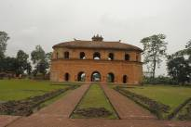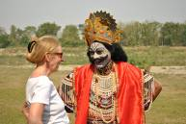

We enjoy hot lunch on MV Mahabaahu and sail towards the closest Mishing Village.
The Mishings live on the bank of river in ‘Chang ghars’, houses with raised platform. All Mishing women are expert weavers. The indoor life of a Mishing person revolves around the kitchen area where the family can get together.

After the Mishing Village MV Mahabaahu heads towards Dhansiri Mukh where the waters of Bhramaputra and Dhansiri meet, while we enjoy a talk on ‘Assam, its geographical location & importance’. We then enjoy the evening under the stars on a deserted island and proceed for dinner.

Meals included: Breakfast, Lunch & Dinner
Overnight on board MV Mahabaahu
DAY 06/WEDNESDAY BOAT SAFARI
After Yoga and an early morning walk on a deserted island MV Mahabaahu sails towards the Eastern Range of Kaziranga for boat Safari. We enjoy breakfast and a talk on ‘The River Brahmaputra and the life that exists alongside’.

We proceed for the safari in our tenders for about two hours. The shores are high but one can see roof turtles on protruding drift wood, water lizards, otters, elephants, wild buffaloes, rhinos, darters, herons, pied kingfishers, white throated kingfishers, serpent eagles and many more. The sightings are always determined by the weather conditions.We return for lunch. This evening we enjoy the Chef’s Cooking Demonstration followed by a talk on ‘Tea, Silk and Jute in Assam.’

The evening on a deserted island with bonfire is always unusual. We enjoy dinner on MV Mahabaahu. (Bonfire may be avoided if a suitable sandbank cannot be found or if we experience inclement weather conditions)

Meals included: Breakfast, Lunch & Dinner
Overnight on board MV Mahabaahu
DAY 07/THURSDAY WEAVER’S VILLAGE AT BISHWANATH GHAT/ SAIL TO SILGHAT/ TEA ESTATE VISIT AND/OR JUTE MILL

After Yoga/walk on the deserted island and breakfast, we enjoy an interesting talk on ‘Kaziranga and the wild life in India’. Then we step into our tenders to go to the shores of Bishwanath Ghat.
We visit the Shiva Dol in reverence of Lord Shiva and there is no way that we can avoid the women with their weaves. We enjoy a walk through the village and see how this suburban village thrives.

We sail on for the next couple of hours and enjoy a relaxed lunch and reach Silghat.

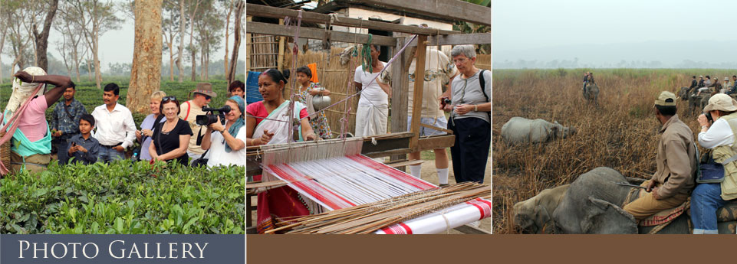

Upon arrival at Silghat, disembark from the cruise. Take a short drive to the Kaliabore tea estate, which is a vast expanse of undulating land with tea bushes, watching the tribal women pick tea leaves. We proceed to the tea factory to see the process of finally producing Assam Tea and coming to terms with ‘all that goes into preparing a cup-of-tea.’ (The tea factory is not operational from mid- December to mid -February as the tea is at its dormant stage during this time of the year)

Meals included: Breakfast, Lunch & Dinner
Overnight on board MV Mahabaahu

DAY 08/FRIDAY KAZIRANGA NATIONAL PARK/ SAIL TOWARDS A DESERTED ISLAND

We rise very early today and after a warm cup of tea and some snacks, drive out towards the Kaziranga National Park. The most prized inhabitant of Kaziranga is the Greater One-Horned Indian Rhinoceros, but the Park is home to as many as 180 different mammals including wild elephants, tiger, deer, Asiatic wild buffalo and a rich variety of birds.
We reach the Kohora Mihimukh range of the National Park and are ready to start our morning adventure; once-in-a-lifetime elephant-backed safari where we search for the elusive rhinoceros, tigers, swamp deer and hog deer and more and a large number of very interesting birds. The park never ceases to surprise us.

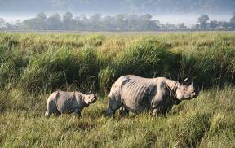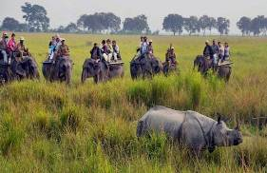

After breakfast at a resort in Kaziranga, we drive on to Bagori, the Western Range of Kaziranga and get into the open jeeps for some more wild life adventure and an extensive coverage of this magnificent park.

We return to MV Mahabaahu for a leisurely lunch and a relaxed afternoon.

After the leisurely pace of the day and having recovered the lost sleep, we once again get together for the traditional Assamese theme dinner.

(In October and May when Kaziranga National Park is closed we do a short Jeep Safari in the outer area of the Kaziranga National Park. Elephant safari is not possible but one can opt for elephant joy ride on the outskirts of the park. During these two months we have an additional Boat Safari in a very picturesque area at the confluence of Diphlu and Brahmaputra River).

Meals included: Breakfast, Lunch & Dinner
Overnight on board MV Mahabaahu
DAY 09/SATURDAY A VILLAGE VISIT/ FULL DAY SAIL/ PEACOCK ISLAND

We catch up on Yoga on an island or on the deck for an hour and move on to breakfast while MV Mahabaahu lifts anchor and heads on towards an island that is occupied predominantly by a 9angle speaking Muslim community who are involved in extensive farming. After breakfast we enjoy a talk on ‘Kamakhya and the Occult and Peacock Island and then proceed for a visit to get an insight on village life.

We return to the ship for lunch and sail towards the Peacock Island that is home to some Golden Langurs.

After the Peacock island visit, we sail towards Pandu Port and anchor at a jetty. We get ready for the Farewell Dinner ‘Alvida Bhoj’ and enjoy a relaxed evening.

Meals included: Breakfast, Lunch & Dinner
Overnight on board MV Mahabaahu

DAY 10/SUNDAY GUWAHATI/ KAMAKHYA TEMPLE VISIT/ GUWAHATI

We have a relaxed breakfast.

The crew on-board organises our transport and with packed lunch we drive to the Kamakhya Temple. This Temple is devoted to the eternal feminine; the goddess of desire whose name is Kama Khya, granter of desires.

We arrive at the International airport in Guwahati and bid farewell to the land of Kamakhya.

Meals included: Breakfast & Packed Lunch
Overnight at hotel
DAY 11/MONDAY GUWAHATI - DARJEELING

Breakfast at hotel.

In time transfer to Guwahati airport to board a flight to Bagdogra. On arrival in Bagdogra, transfer by road to Darjeeling covering a distance of 80kms in approx. 2 – 3 hours

Arrive Darjeeling and check in at your hotel for overnight stay.

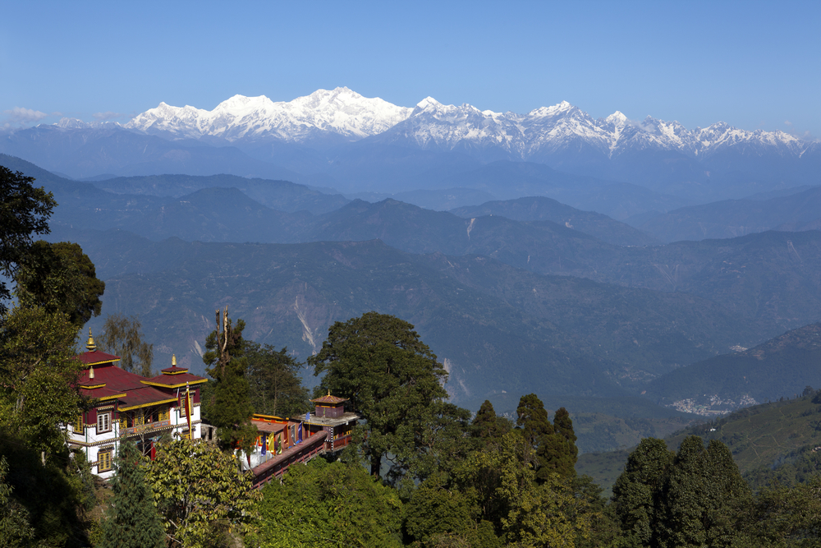

Darjeeling: Spread in ribbons over a steep mountain ridge, surrounded by emerald-green tea plantations and towered over by majestic Khangchendzonga (8598m), Darjeeling is the definitive Indian hill station and is arguably West Bengal’s premier attraction. When you aren’t gazing open-mouthed at Khangchendzonga, you can explore colonial-era architecture, visit Buddhist monasteries, and spot snow leopards and red pandas at the nearby zoo. The adventurous can arrange a trek to Singalila Ridge or hire a mountain bike for a guided ride around the hilltops. And finally, when energies start to flag, a good, steaming Darjeeling brew is never far away.
Rest of the day at leisure to explore on your own.

Meals included: Breakfast, Lunch & Dinner
Overnight at hotel
DAY 12/TUESDAY DARJEELING - MANYBHANJANG - TUMLING

Breakfast at hotel.

Early morning tour to Tiger Hills (8364 ft. /2550 mts at around 4 a.m.) to view sunrise over Kanchendzonga Peak (subject to clear weather). On way back visit Ghoom Monastery & Batasia.

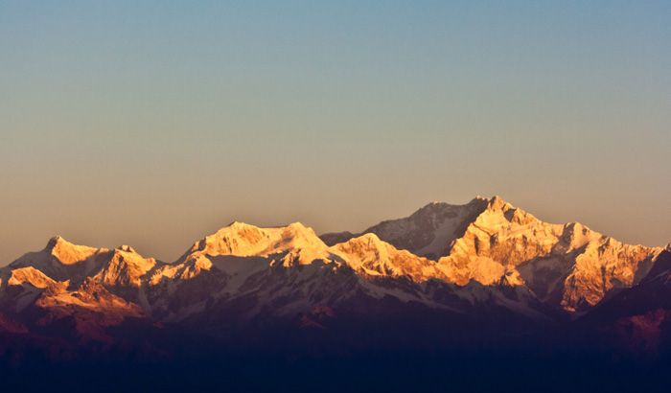

After breakfast drive to Manybhanjang (7000 Ft / 2134 mts, 30 km / 1.5 hrs.), it is a small village inhabited by Buddhist Sherpas.

Upon arrival in Manybhanjang, one could relax or explore the town. You trek from Manybhanjang to Tumling (9742 Ft / 2970 mts, 11 km/ 5 hrs. walk), walk ranging from the moderate to the tough. You will pass through dense forests in which bloom exotic wild flowers. Look for exotic orchids on top of tall trees or on mossy rock ledges. Tumling provides a gorgeous view of the majestic Kanchenjunga on one side and the towns of Darjeeling & Kurseong dotting the landscape on the other.

Meals included: Breakfast, Lunch & Dinner
Overnight at Trekkers Hut
DAY 13/WEDNESDAY TUMLING - MANYBHANJANG - DARJEELING

After breakfast trek back to Maneybhanjang from where you will board your vehicle & will drive to Darjeeling covering a distance of 30 km in approximately 1 hour and 30 minutes.

Day at leisure to explore on your own.

Meals included: Breakfast, Lunch & Dinner
Overnight at hotel
DAY 14/THURSDAY DARJEELING – PELLING

Breakfast at hotel.

Transfer to Pelling (6100 ft. / 1890 mts.) covering a distance of 125 kms in approximately 6 hours.

Arrive in Pelling and check-in at hotel for an overnight stay.

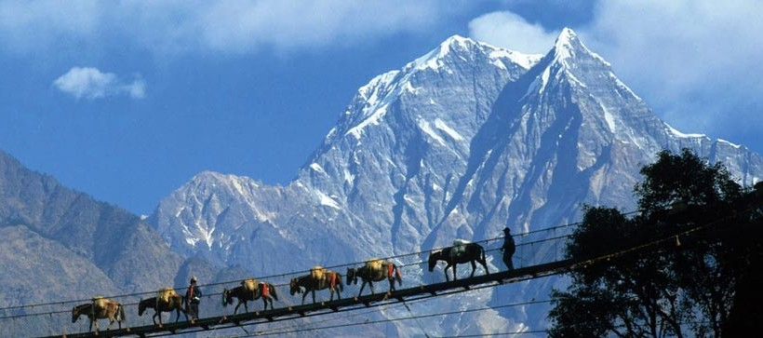

Afternoon cover Pemayangtse Monastery which belongs to the Nyingma-pa order of Tibetan Buddhism. It was built as a small temple in late 17th century by Latsun Chenpo. On the top floor there is a wooden sculpture portraying the Mahaguru’s Heavenly palace Sangthokpalri & Rabdengtse palace ruins - once the second capital of Sikkim is now a historical monument.

Meals included: Breakfast, Lunch & Dinner
Overnight at hotel
DAY 15/FRIDAY PELLING – GANGTOK

Breakfast at hotel.

Transfer to Gangtok (5500 ft. / 1677 mts.) covering a distance of 116 kms in approximately 5 hours.

Arrive in Gangtok and check-in at hotel for 2 nights.

Later drive to Gangtok; at an altitude of 1750m, Gangtok became the state capital in the mid-19th century and has undergone rapid development since then. The downtown area is dominated by huge government buildings decorated with traditional Buddhist symbols. Gangtok is also a resting ground for people traveling to North Sikkim. Surrounded by Monasteries and Orchids, Gangtok is truly a traveler’s delight.

Rest of the day is at leisure to explore on your own.

Meals included: Breakfast, Lunch & Dinner
Overnight at hotel
DAY 16/SATURDAY GANGTOK

Breakfast at hotel.

Go for a half day sightseeing covering Rumtek Monastery, Droul Chorthen, Research Institute of Tibetology, Directorate of Handicraft & Handloom & Flower Show.

Rumtek Monastery: 24 Kms. from Gangtok is the awe -inspiring Rumtek Monastery, the world Dharma chakra Centre and the seat of His Holiness, the Gyalwa Karmapa, who is the head of the Kagyupa order of Tibetan Buddhism. Behind the main monastery is the lavishly decorated Karmae Nalanda Institute of Buddhist Studies, which attracts students from the world over. Opposite the entrance to the Institute is a small hall featuring a beautiful jewel studded Chorten the Golden Stupa, which contains the ashes and remains of His Holiness the xvi Gyalwa Karmapa. According to legend, it is believed that after years of meditation, the first Karmapa was said to have been visited by ten thousand fairies who came to congratulate him each of whom offered a strand of her hair as a gift. These were said to have been woven into a black hat, which was passed down and is still at the Rumtek Monastery today. It is said that unless held on to by the wearer (who of course, cannot be anyone else but the Karmapa) or kept in a box, the hat would fly away
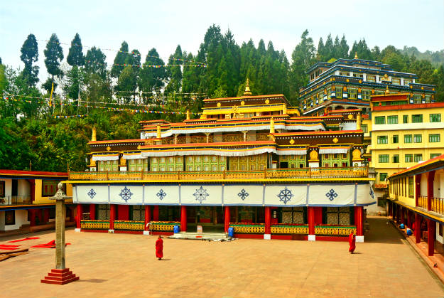

Namgyal Institute of Tibetology: -Amidst a serene surrounding of oak, birch and ash lies the
unique organization established in1958. Built in traditional style, the namgyal Institute of
Tibetology promotes research in Mahayana Buddhism and the language and tradition of Tibet. It has one of the world’s largest collections of rare books and manuscripts on Mahayana Buddhism. The Institute also has a retail outlets where related books and commercially produced religious art and craft of Tibet can be bought.

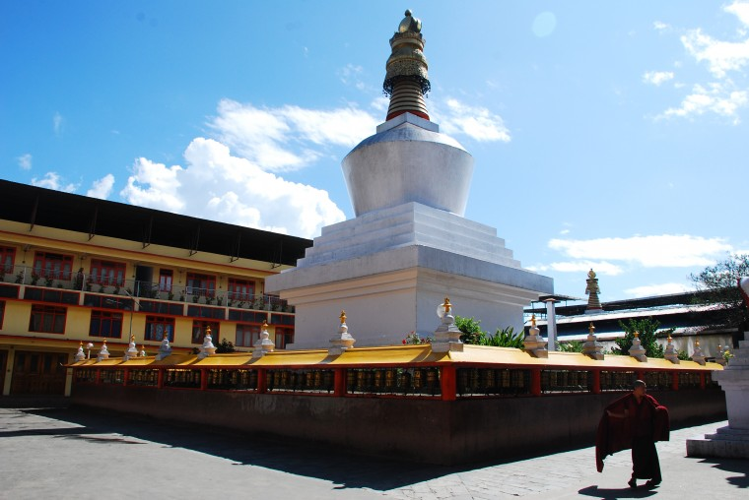
Adjacent to the institute are two exquisite stupas, the Do Drul Chorten, built to commemorate the victory of good over evil and the Jhang Chub Chorten, built in the memory of Thrukshik Rinpoche, an ardent devotee, a great spirtualist and interpreter of Buddhism. Near the Chorten are housed two giant statues of Lord Buddha and Guru Padmasambhava, also known as Guru Rimpoche, the patron saint of Sikkim.

Directorate of Handloom and Handicrafts: -This Directorate was set up to promote traditional Sikkimese art and handicrafts. Exquisitely carved wooden friezes, intricate bamboo work, along with beautiful hand woven carpets and handlooms are on exhibit here. Visitors can not only purchase these items here but also see the artisans at work. Among others, a favorite item here is the choktse a wooden table with carved panels that can be folded into a portable pack.

Meals included: Breakfast, Lunch & Dinner
Overnight at hotel
DAY 17 GANGTOK- BAGDOGRA

Breakfast at hotel.

In time transfer to Bagdogra airport covering a distance of 130 kms in approximately 4 to 5 hours for your flight to onward destination.

Meals included: Breakfast

TOUR END

